1. No of book/eBook publisher

Link- <https://publishingperspectives.com/2011/07/publishing-in-india-today-19000-publishers-90000-titles/#:~:text=Publishing%20in%20India%20Today%3A%2019%2C000%20Publishers%2C%2090%2C000%20Titles%2C%20Many%20Opportunities,-In%20Growth%20Markets>

According to 2011 survey there are 19000 publishers are present in India.

 It is estimated that organized retail accounts for a mere 7% of book sales, with the rest coming from the unorganized sector, which includes channels such as supermarkets, university bookstores, textbook stores, railway-station stalls, door-to-door sales agents, footpath sales, etc. There has certainly been an upsurge in shelf space for books, at least in the major metropolitan areas, while online retail outfits such as [Flipkart](http://www.flipkart.com/) and [InfiBeam](http://www.infibeam.com/) have belied earlier predictions to become serious players in the business in India. Flipkart in particular claims to have four million titles readily available to its six million visitors and 500,000 registered users; its book sales have reached 750,000 in just over two years of its existence, with half of its buyers returning to make additional purchases.

1. No of titles

Link- [https://timesofindia.indiatimes.com/life-style/books/features/Can-Indian-authors-afford-to-pursue-writing-as-a-full- time-career/articleshow/29993883.cms#:~:text=Over%201500%20fiction%20books%20get,copies%20last%20year%20in%20India](https://timesofindia.indiatimes.com/life-style/books/features/Can-Indian-authors-afford-to-pursue-writing-as-a-full-%20%20%20%20%20%20time-career/articleshow/29993883.cms#:~:text=Over%201500%20fiction%20books%20get,copies%20last%20year%20in%20India)

. Over 1500 fiction books get published in India every year.

Link- <https://www.thehindu.com/books/authors-are-vying-with-pokmon-and-taylor-swift-meghna-pant/article26606836.ece>

. According to the India Book Market Report (2016).

educational books, publishing is a $6.76 billion sector expected to grow at an astounding 19.3% until 2020 (Nielsen Report, 2016). This means almost 250 books are published per day. 55% sales are of English books, 35% of Hindi, and the rest are regional-language books.

Link- <https://www.worldometers.info/books/>

. new book title published this year- 1905590

. India -India (2004) 82,537 (21,370 in Hindi and 18,752 in English)

.

1. Revenue-

India's book market, currently worth Rs 261 billion making it the sixth largest in the world and the second largest of the English language ones, is expected to touch Rs 739 billion by 2020, says a survey.

<https://economictimes.indiatimes.com/industry/media/entertainment/media/indian-book-market-to-touch-rs-739-billion-by-2020-survey/articleshow/49996781.cms?utm_source=contentofinterest&utm_medium=text&utm_campaign=cppst>

* Revenue in the eBooks segment is projected to reach ₹13,787m in 2020.
* Revenue is expected to show an annual growth rate (CAGR 2020-2025) of 7.2%, resulting in a projected market volume of ₹19,521m by 2025.
* User penetration will be 6.8% in 2020 and is expected to hit 8.7% by 2025.
* The average revenue per user (ARPU) is expected to amount to ₹146.07.
* Link- <https://www.statista.com/outlook/213/119/ebooks/india?currency=inr>
* 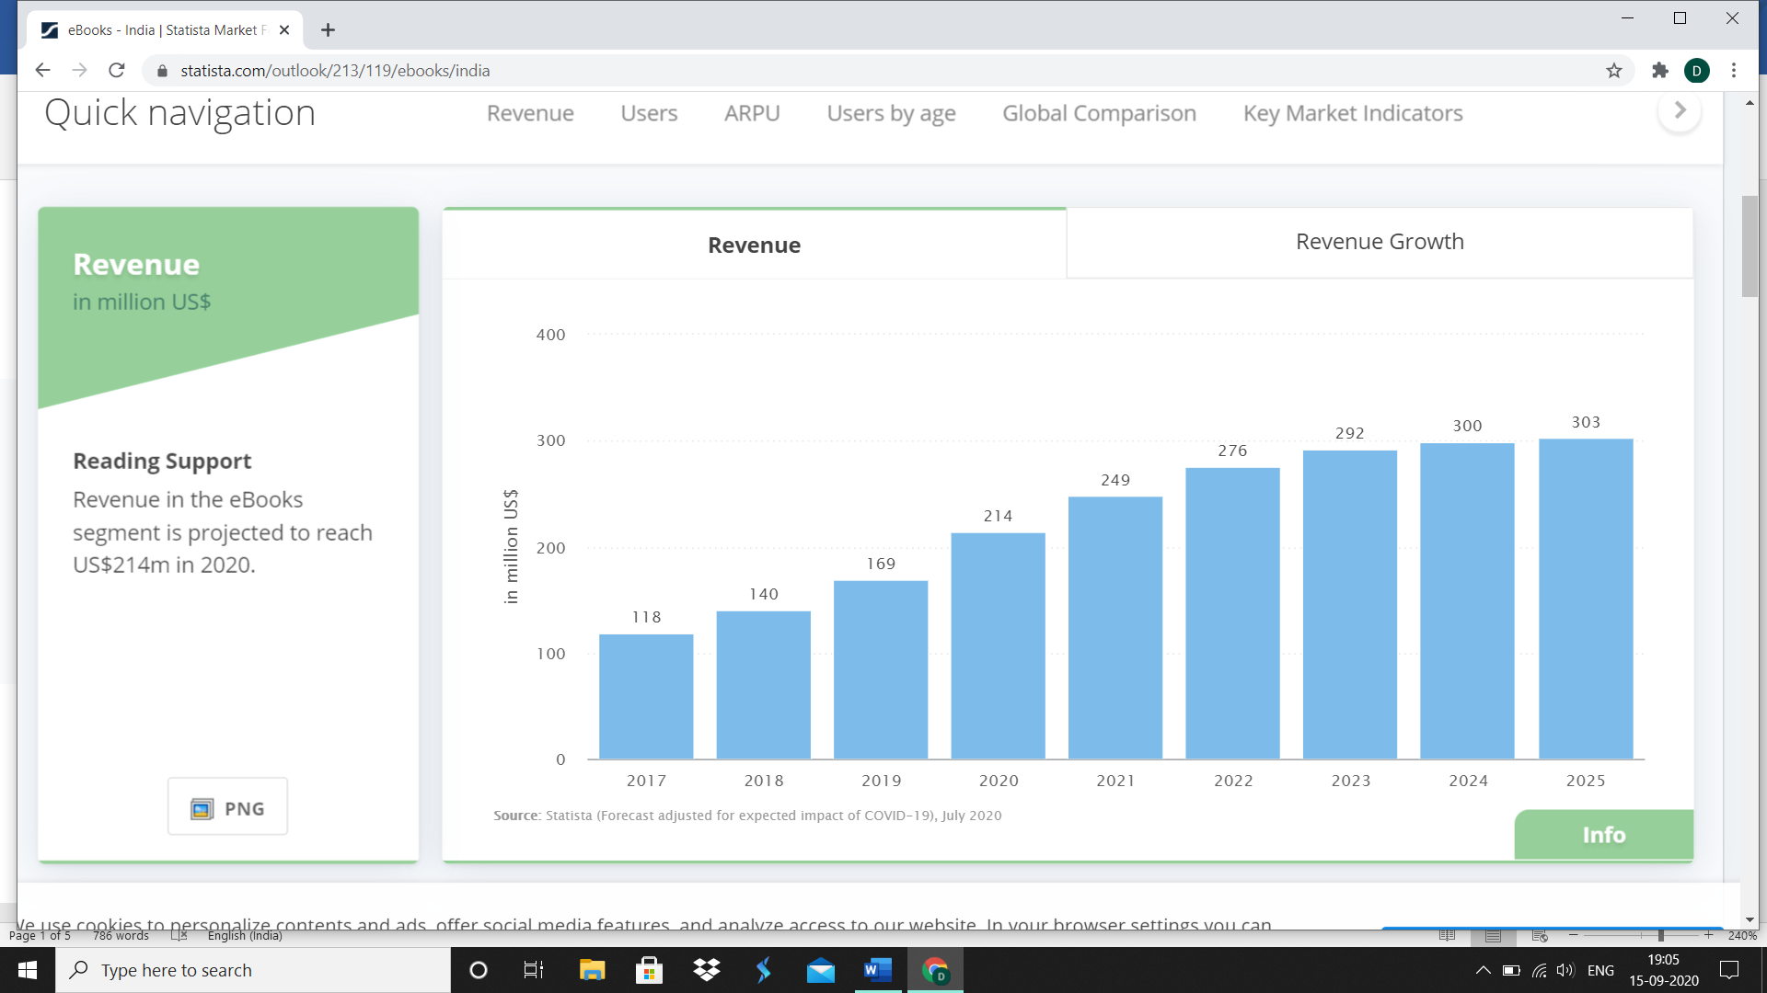
* 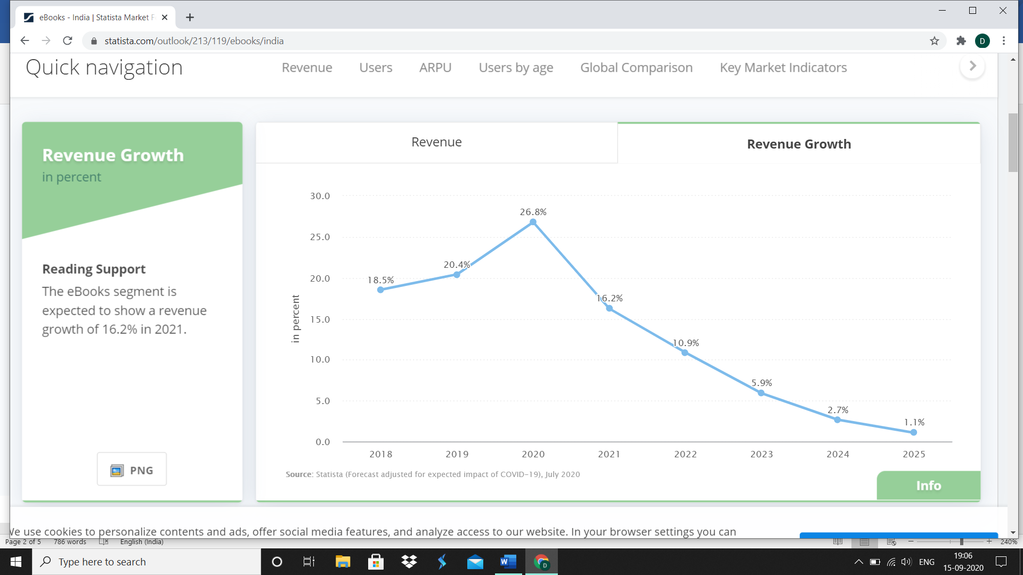

NO OF E-BOOK USERS-

* 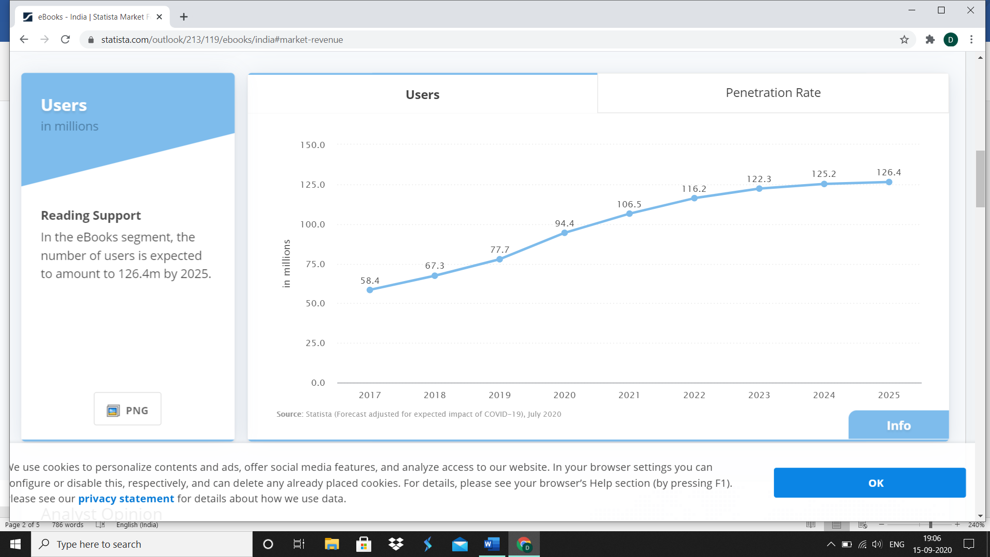
* 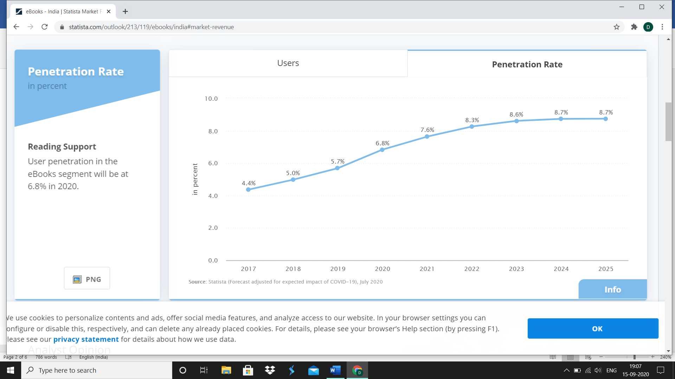

AVERAGE REVENUE PER USER (E-BOOK)

* 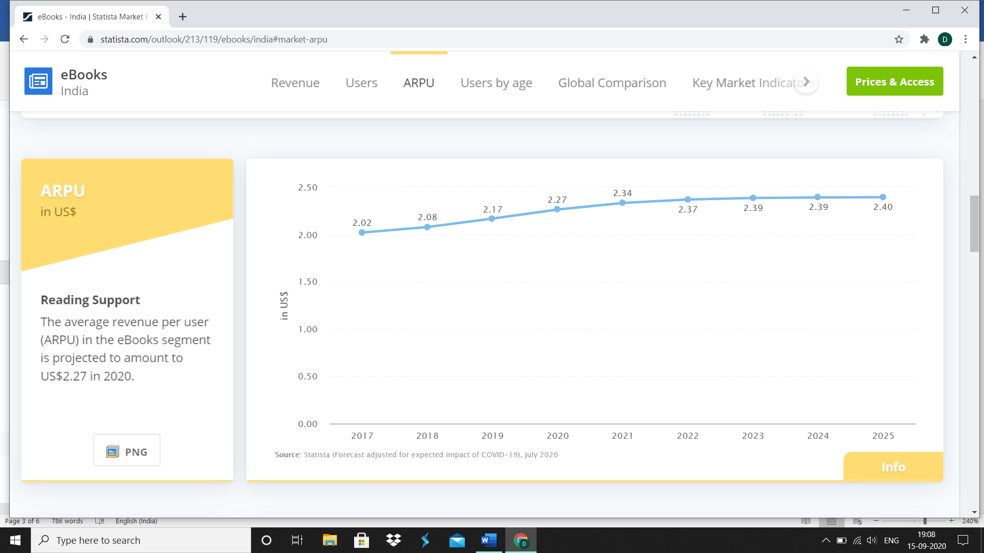

E-BOOK USER BY AGE

* 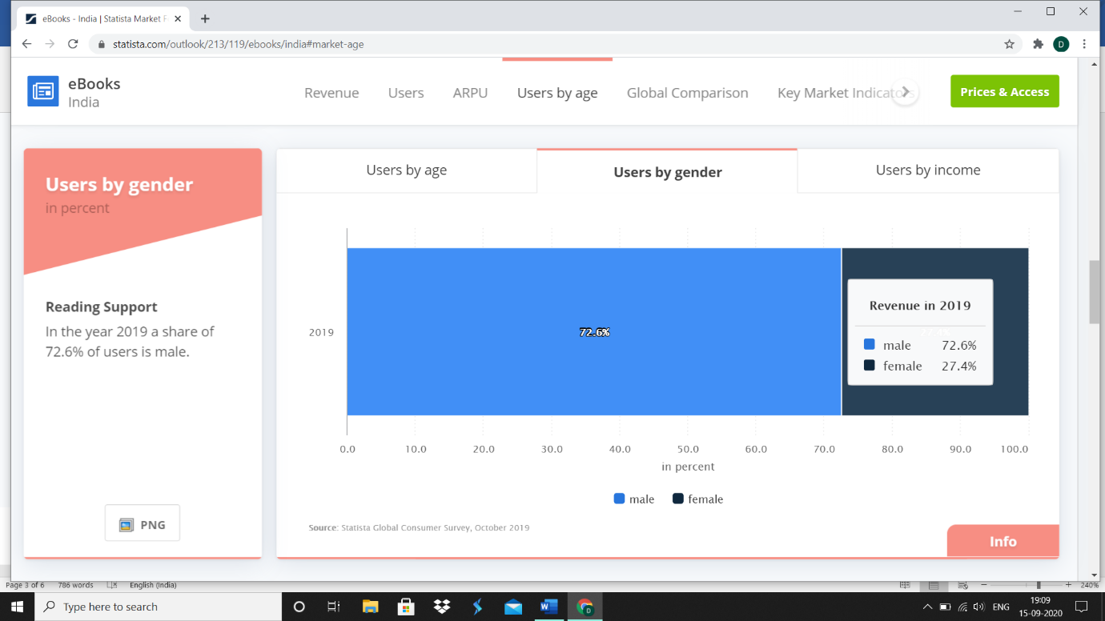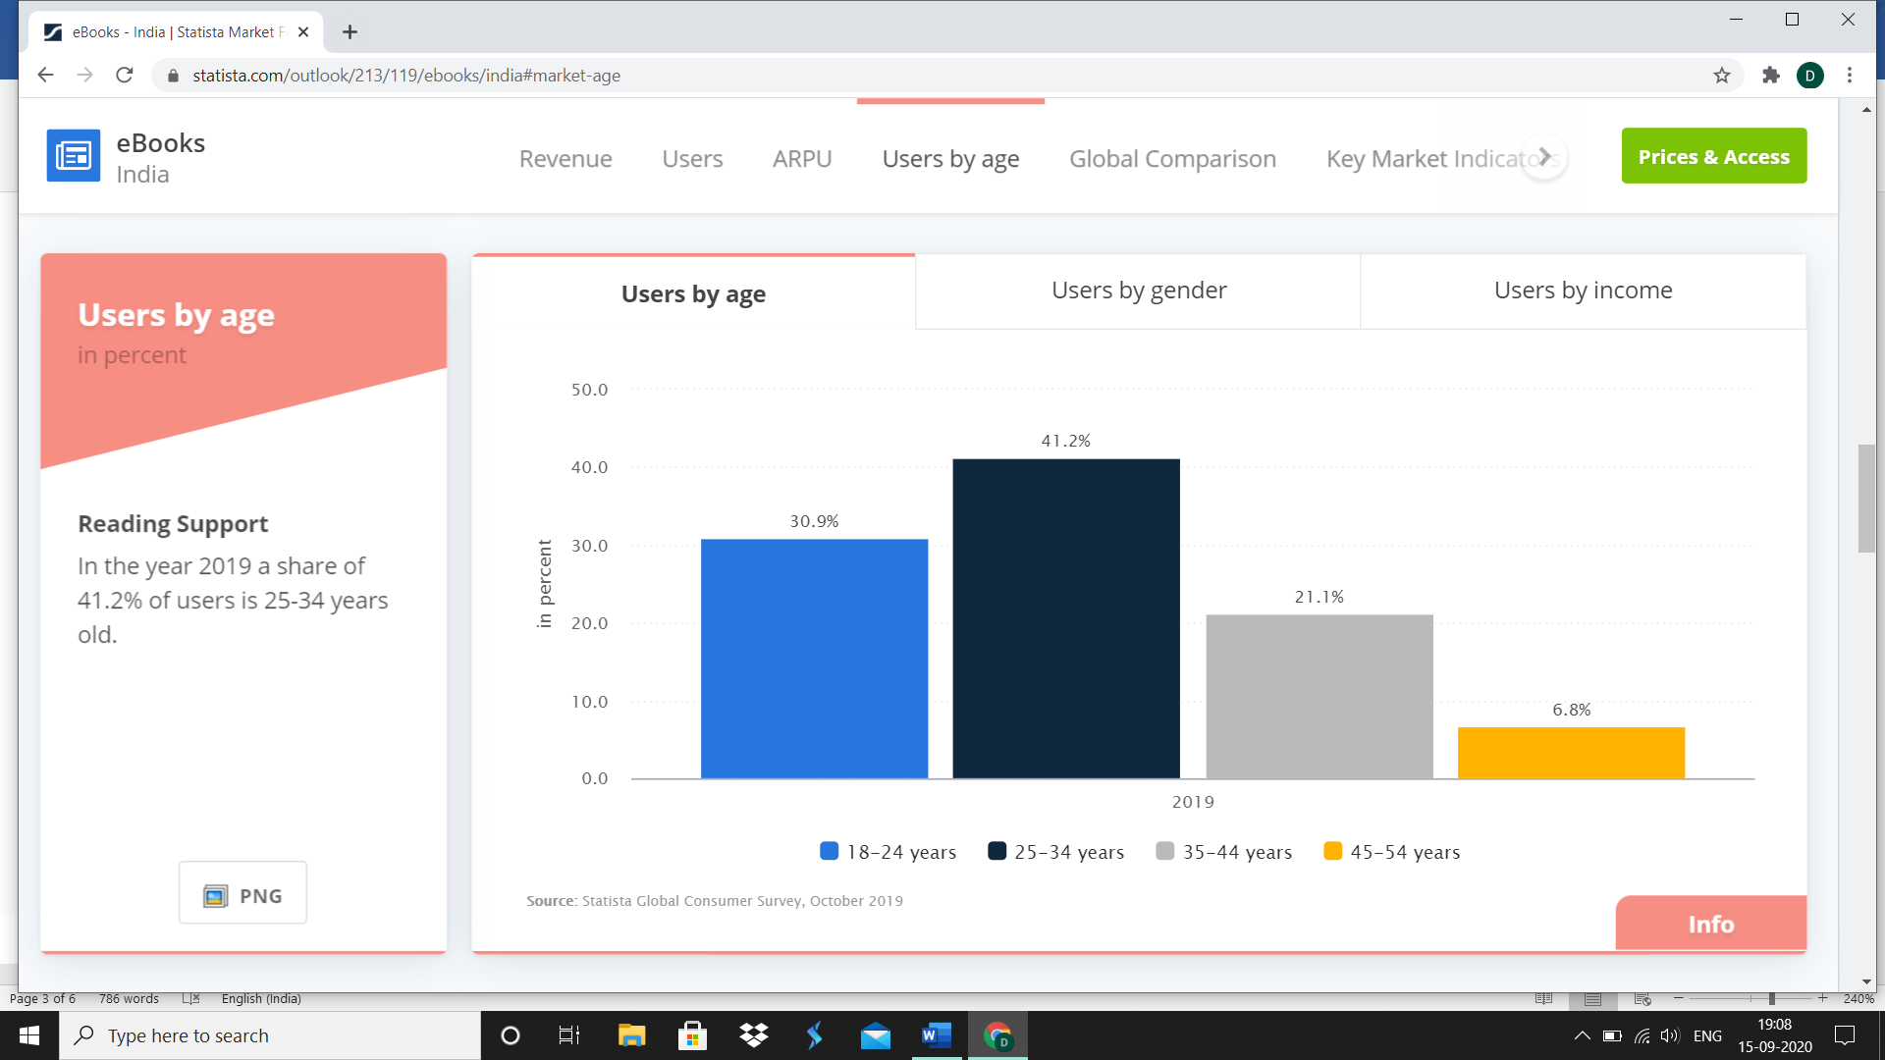

NO OF E-BOOK USER BY GENDER

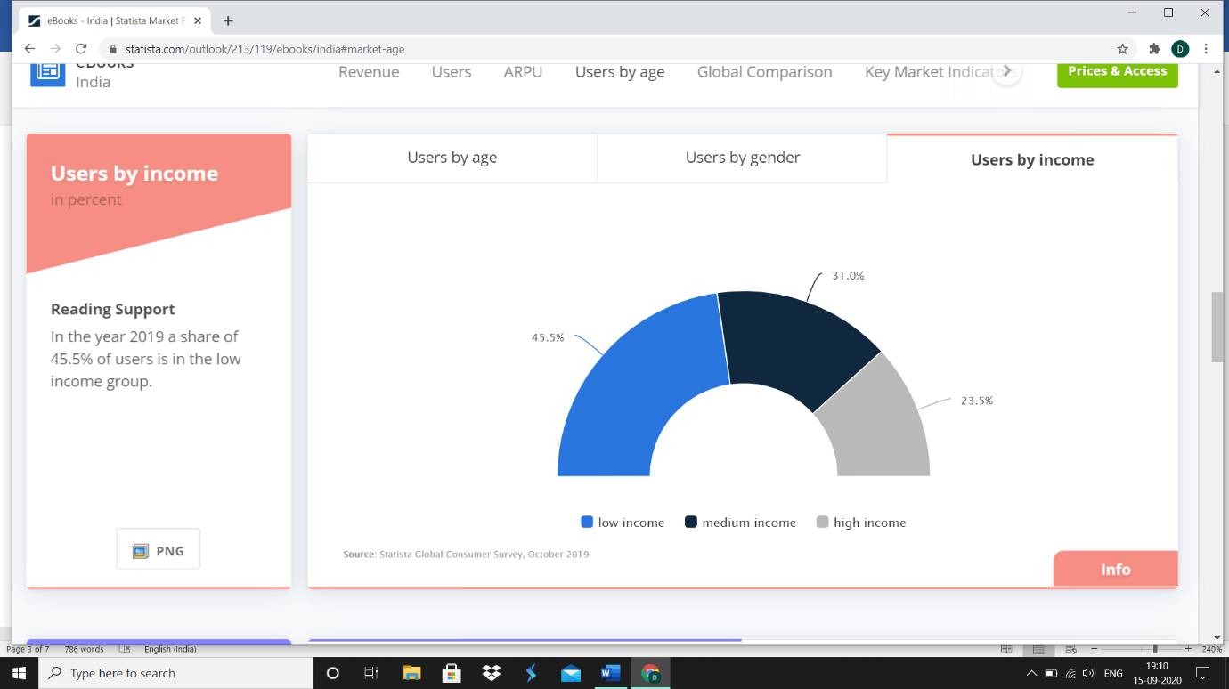

MARKET SHARE OF BOOKS-

<https://economictimes.indiatimes.com/industry/media/entertainment/media/indian-book-market-to-touch-rs-739-billion-by-2020-survey/articleshow/49996781.cms?utm_source=contentofinterest&utm_medium=text&utm_campaign=cppst>

India is the second largest English-language print book publisher in the world with over 9000 publishers.

More than 70 per cent of publishers in India have digitised their content to produce e-book versions.

"general and literary fiction" was ranked the #1 genre in the trade books segment while "test prep" was the most sought after genre in Academic books.  
1st genre in the trade books segment - "general and literary fiction”.

2nd –“test prepration”

55% per cent of trade sales are of books in English. Books in Hindi account for 35% of Indian language sales, but the largest share of these sales is taken by "Others,".

Link- <https://medium.com/@amishmulmi/is-indian-publishing-really-growing-at-30-percent-per-year-6c092eded80a>

which ‘[covers a significant market of organised book sales in India. The shop panel has increased since its launch and current coverage is approx 300,000 units at a value of INR 80 million and 70,000 different titles (ISBNs) each week.](http://www.nielsenbookscan.co.uk/controller.php?page=1021)’

The report said

[‘India is the 6th largest book market in the world, and currently the 2nd largest for books in English, behind the United States… Nielsen’s survey among urban consumers shows that they buy more educational books than trade books. **The educational books sector, which forms 70% of the book market in India, is the bulwark for the publishing industry**…Out of the 9,037 publishers identified in the Nielsen report, 8,107 publish books for schools, colleges and higher educational institutions. **Only 930 are trade publishers**…the schoolbooks market in 2013–14 was worth Rs. 18,600 crore, and the market for books for higher education was valued at Rs. 5,600 crore in the same period. **The trade books market was valued at Rs. 1,860 crore, a figure which would no doubt be higher if publishers not covered by BookScan, especially those who publish books in Indian languages, were added to the count**. But educational publishing would still make for a large portion of the entire book market](http://www.caravanmagazine.in/reviews-essays/numbers-and-letters-india-publishing-industry).

To quote Nielsen: [‘Nielsen’s forecasts for market growth in the educational book sector show this already extremely significant market growing by some 19% over the next five years…purchases of K-12 (kinder-garten till Grade 12) school books are estimated to account for some 71% of the market, with higher education books accounting for an additional 22%.’](http://www.nielsen.com/in/en/insights/news/2016/read-all-about-it-indias-book-market-is-poised-for-growth.html)

 According to the 2009 National Youth Readership Survey, three out of four youths in the country are literate, and a quarter of the youth population (an astonishing 83 million) identify themselves as book readers

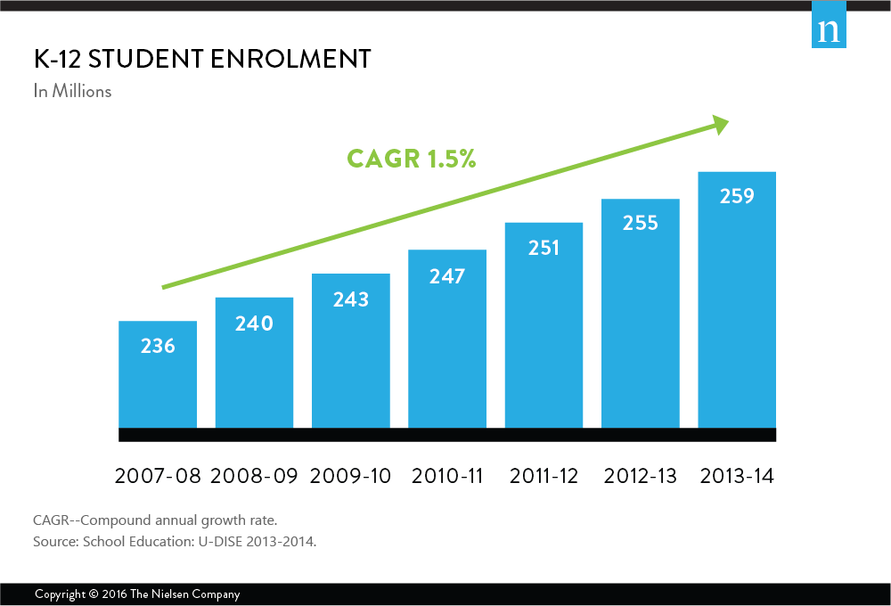

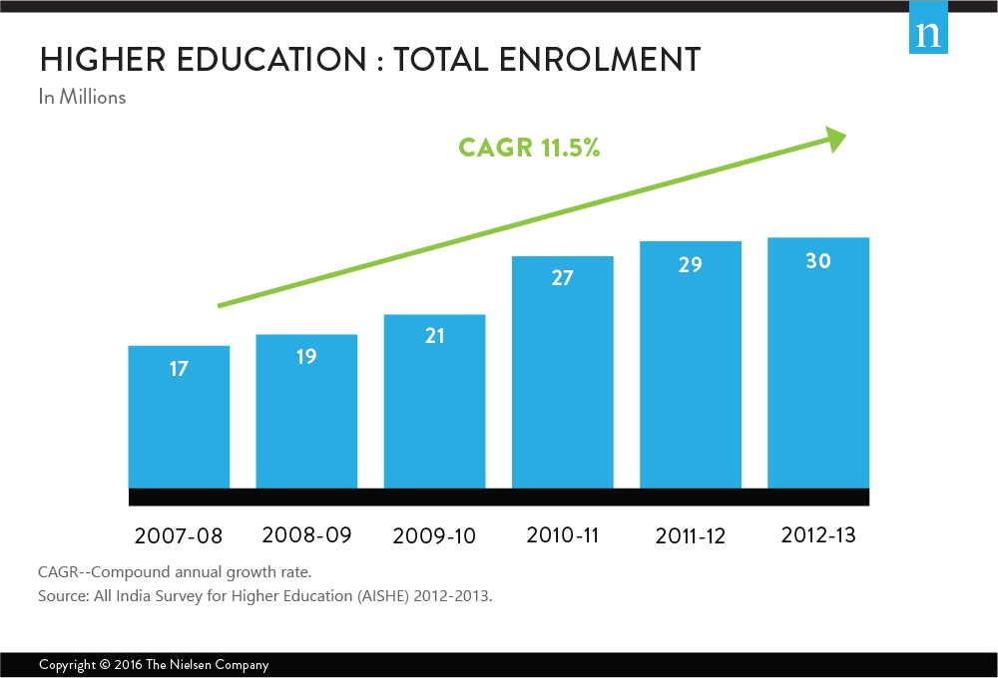

Link- <https://www.statista.com/statistics/978512/india-sources-of-book-consumption/>

According to 2019-

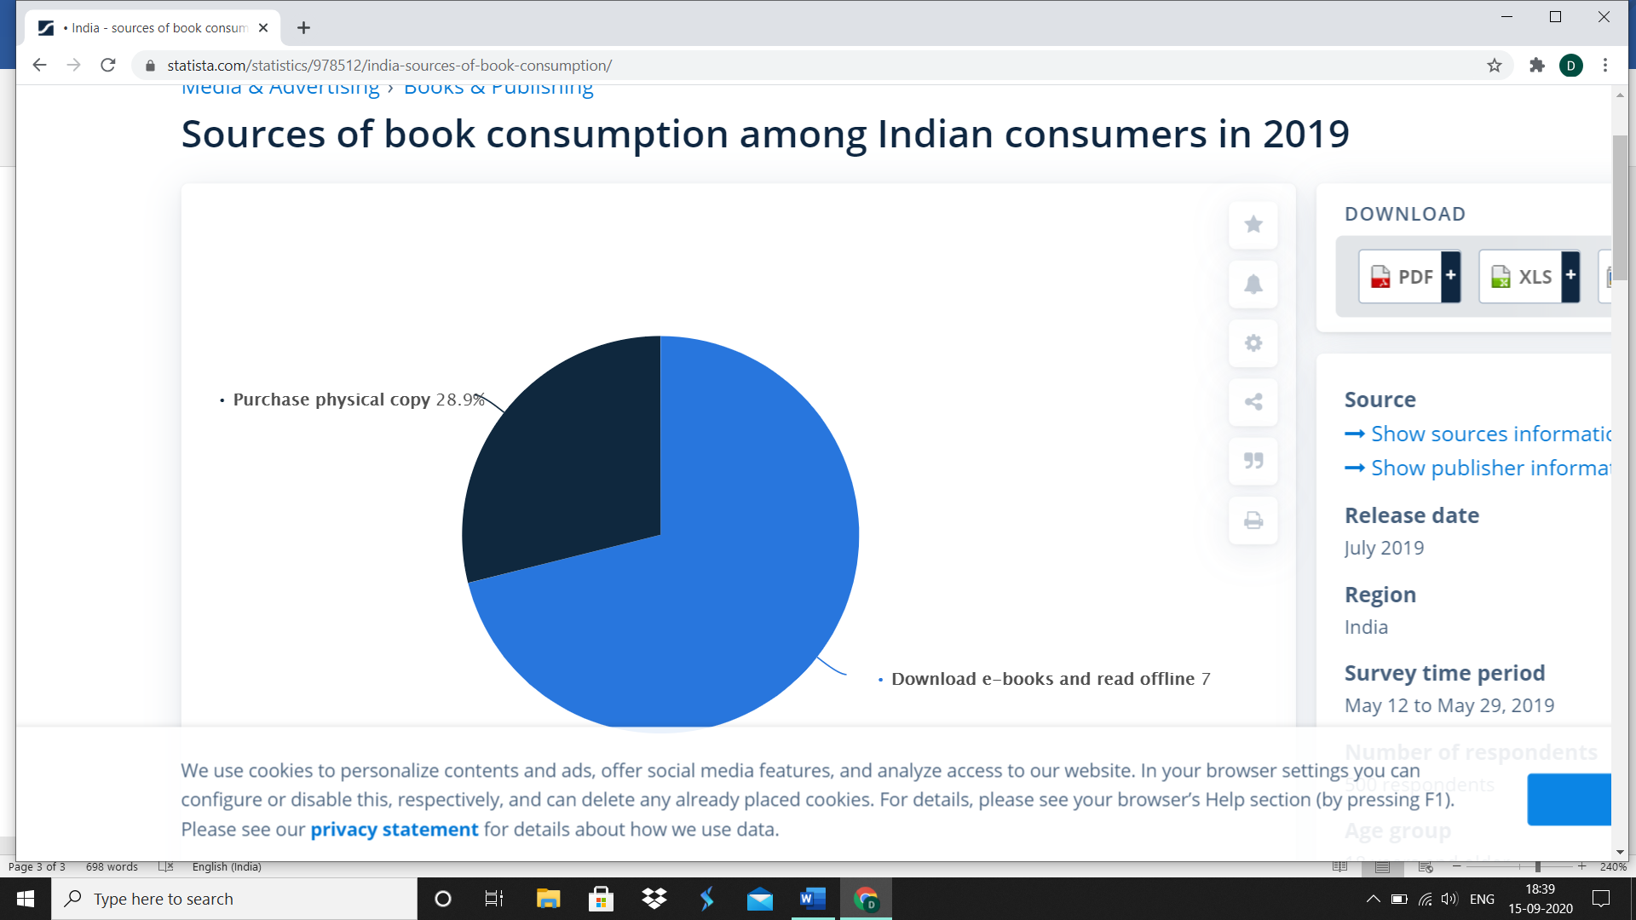

Link- <https://www.moneycontrol.com/news/trends/data-story-indians-spend-more-time-reading-than-anyone-else-in-the-world-2425835.html>

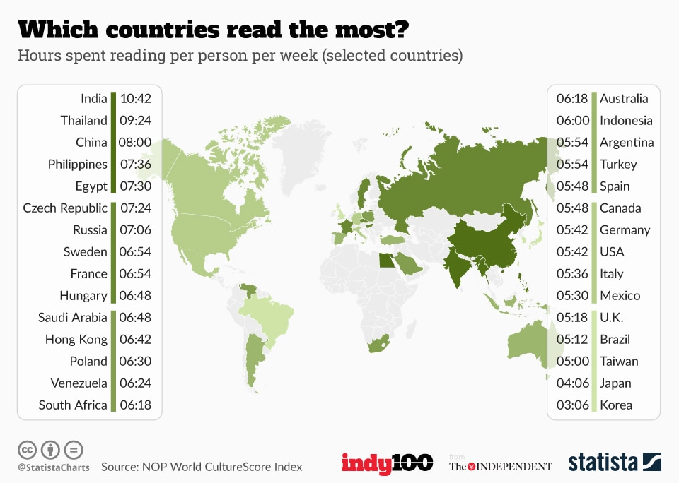

Read more at: <https://yourstory.com/2018/01/5-takeaways-amazon-indias-reading-trends-report-2017>

RANK OF WELL READ CITY

1. Bengaluru, 2. Mumbai, 3. Delhi, 4. Chennai, 5. Hyderabad, 6. Pune, 7. Kolkata, 8. Gurgaon, 9. Noida, and 10.